Complete Angle
# Source: AI Source: Provided by: [Data Path: Persons Table -> ID Column: 1, Name_En Column: Motasem Essam] -> From: [ChatGPT] on [7/25/2026]
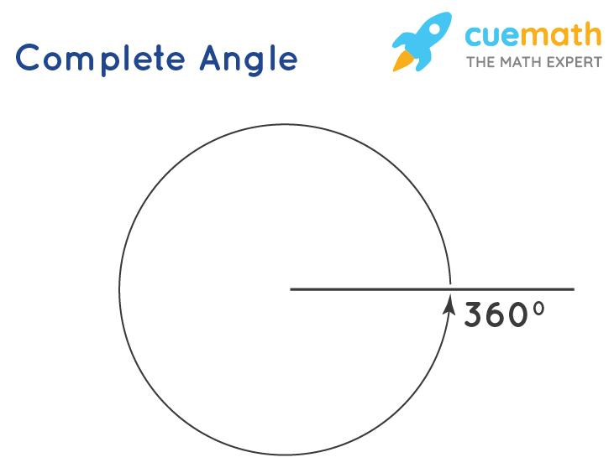
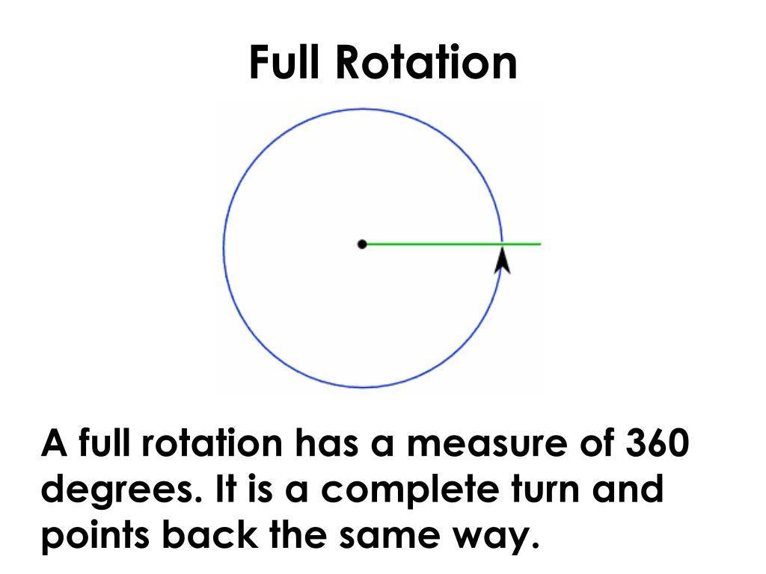
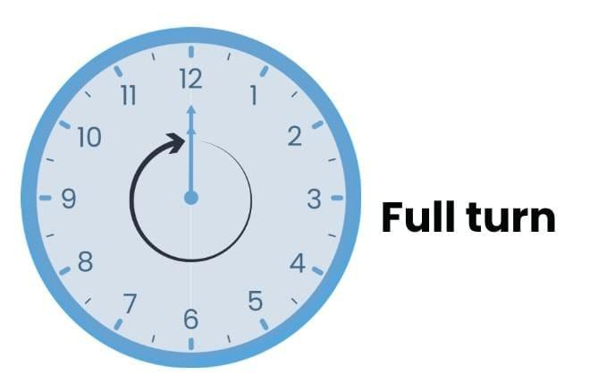
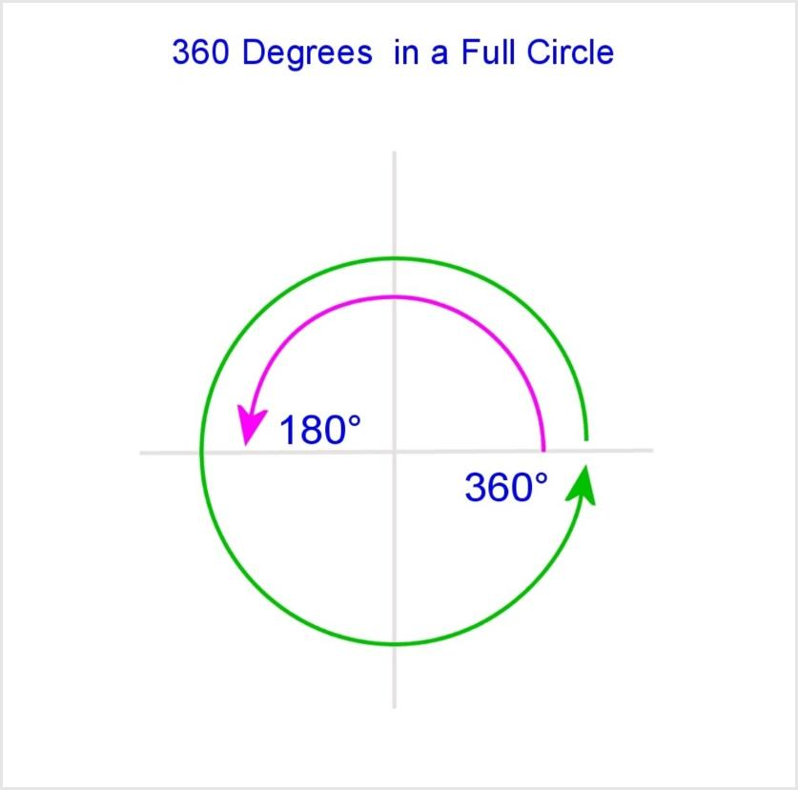
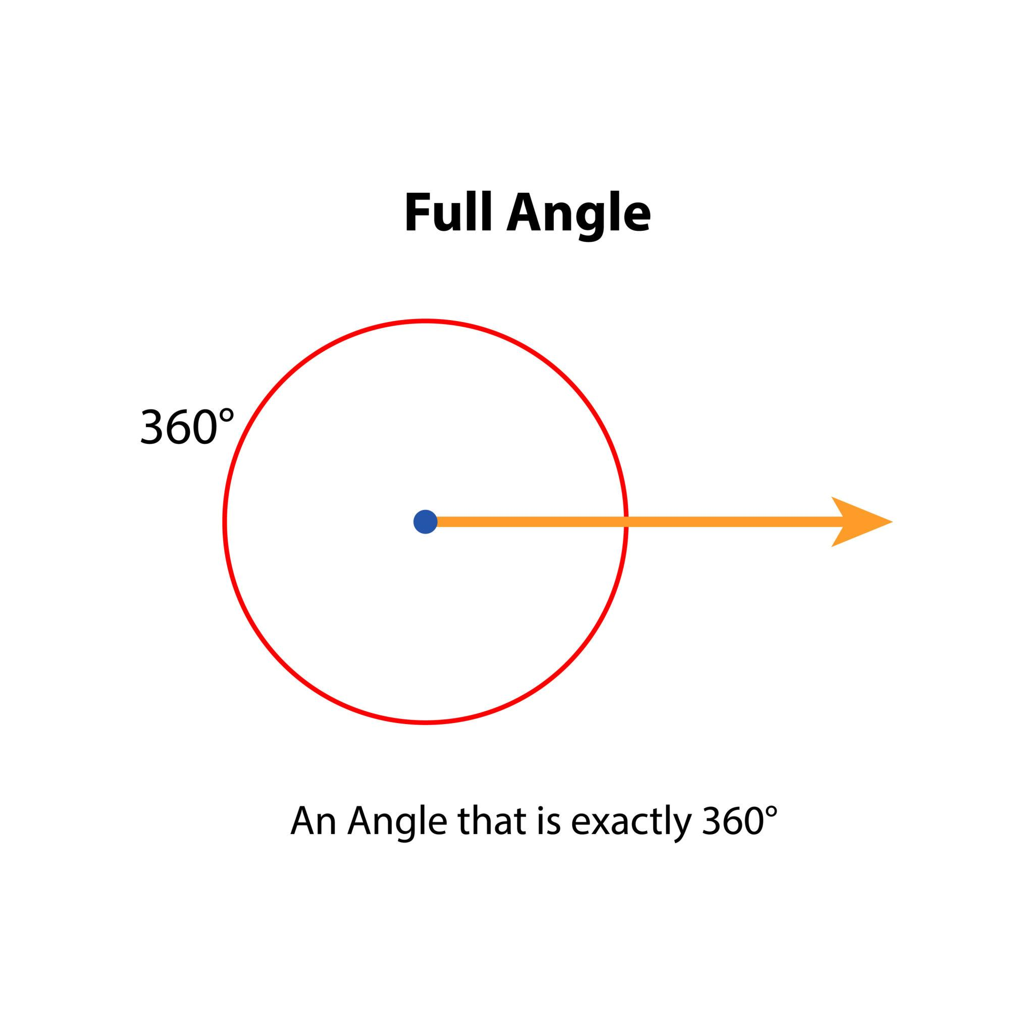
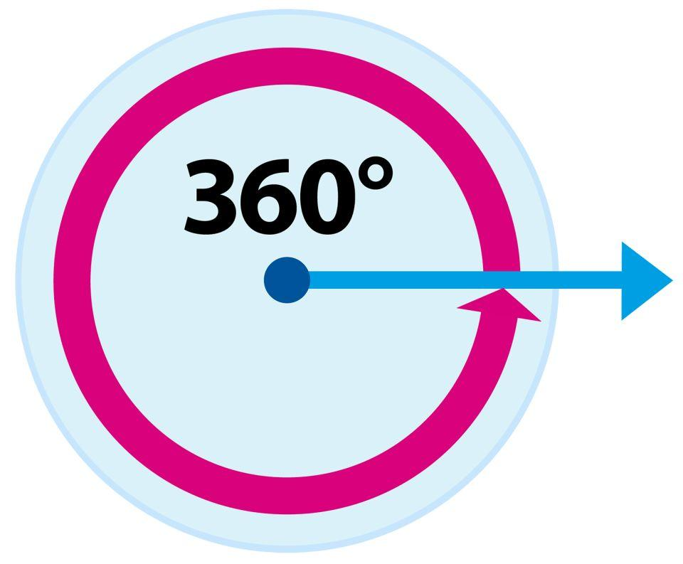

Definition
# Source: AI Source: Provided by: [Data Path: Persons Table -> ID Column: 1, Name_En Column: Motasem Essam] -> From: [ChatGPT] on [7/25/2026]
A Complete Angle (also called a Full Angle, Full Rotation, or Perigon Angle) is an angle that measures exactly ${360}^{∘}$. It is formed when a ray makes one complete revolution around its endpoint and returns to its original position.
A complete angle represents one full rotation.

Characteristics
# Source: AI Source: Provided by: [Data Path: Persons Table -> ID Column: 1, Name_En Column: Motasem Essam] -> From: [ChatGPT] on [7/25/2026]
A complete angle:
- Measures exactly ${360}^{∘}$.
- Measures exactly $2π$ radians.
- Represents a full turn around a point.
- Is formed by a ray rotating completely around its vertex.
- The initial and final positions of the ray coincide.
- Contains all possible directions around the vertex.

Illustration
# Source: AI Source: Provided by: [Data Path: Persons Table -> ID Column: 1, Name_En Column: Motasem Essam] -> From: [ChatGPT] on [7/25/2026]
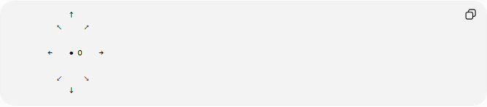
↑
↖ ↗

← ● O →

↙ ↘
↓
The ray completes a full rotation around point O.

Mathematical Representation
# Source: AI Source: Provided by: [Data Path: Persons Table -> ID Column: 1, Name_En Column: Motasem Essam] -> From: [ChatGPT] on [7/25/2026]
A complete angle satisfies:
$$θ={360}^{∘}$$
or:
$$θ=2π\text{ radians}$$

Complete Angle and Rotation
# Source: AI Source: Provided by: [Data Path: Persons Table -> ID Column: 1, Name_En Column: Motasem Essam] -> From: [ChatGPT] on [7/25/2026]
A complete angle represents:
$$1\text{ full rotation}$$
or:
$${360}^{∘}=2π$$
A complete angle can also be divided into:
- Two straight angles:
$${360}^{∘}={180}^{∘}+{180}^{∘}$$
- Four right angles:
$${360}^{∘}=4×{90}^{∘}$$

Examples
# Source: AI Source: Provided by: [Data Path: Persons Table -> ID Column: 1, Name_En Column: Motasem Essam] -> From: [ChatGPT] on [7/25/2026]
Examples of complete angles include:
- A clock hand making one full revolution.
- A rotating wheel completing one turn.
- A compass needle rotating around its center.
- A robot arm making a complete rotation.
- A rotating gear completing one cycle.

Coordinate Geometry
# Source: AI Source: Provided by: [Data Path: Persons Table -> ID Column: 1, Name_En Column: Motasem Essam] -> From: [ChatGPT] on [7/25/2026]
Suppose a ray starts at:
$$O\left(0,0\right)$$
and initially points along the positive x-axis:
$$A\left(5,0\right)$$
After rotating around point (O) by:
$${360}^{∘}$$
the ray returns to the same direction.
The total rotation is:
$$θ={360}^{∘}$$

Properties
# Source: AI Source: Provided by: [Data Path: Persons Table -> ID Column: 1, Name_En Column: Motasem Essam] -> From: [ChatGPT] on [7/25/2026]
A complete angle:
- Has one vertex.
- Represents a full circular movement.
- Is equal to four right angles.
- Is equal to two straight angles.
- Is larger than every other angle type.

Relationship with Other Angles
# Source: AI Source: Provided by: [Data Path: Persons Table -> ID Column: 1, Name_En Column: Motasem Essam] -> From: [ChatGPT] on [7/25/2026]
Complete Angle and Right Angles
$${360}^{∘}=4\left({90}^{∘}\right)$$
Complete Angle and Straight Angles
$${360}^{∘}=2\left({180}^{∘}\right)$$
Complete Angle and Reflex Angles
A reflex angle is always:
$${180}^{∘}<θ<{360}^{∘}$$
while a complete angle is exactly:
$${360}^{∘}$$

Real-World Examples
# Source: AI Source: Provided by: [Data Path: Persons Table -> ID Column: 1, Name_En Column: Motasem Essam] -> From: [ChatGPT] on [7/25/2026]
Complete angles appear in:
- Rotating wheels.
- Clock movements.
- Circular machines.
- Turbines.
- Gears.
- Robotic joints.
- Computer animation rotations.

Applications
# Source: AI Source: Provided by: [Data Path: Persons Table -> ID Column: 1, Name_En Column: Motasem Essam] -> From: [ChatGPT] on [7/25/2026]
Complete angles are used in:
- Plane Geometry
- Coordinate Geometry
- Trigonometry
- Circular Motion
- Engineering
- Robotics
- CAD (Computer-Aided Design)
- Computer Graphics
- Physics

Advantages
# Source: AI Source: Provided by: [Data Path: Persons Table -> ID Column: 1, Name_En Column: Motasem Essam] -> From: [ChatGPT] on [7/25/2026]
Studying complete angles helps to:
- Understand rotational motion.
- Analyze circular systems.
- Work with degrees and radians.
- Understand periodic behavior.
- Design rotating mechanisms.

Limitations
# Source: AI Source: Provided by: [Data Path: Persons Table -> ID Column: 1, Name_En Column: Motasem Essam] -> From: [ChatGPT] on [7/25/2026]
A complete angle:
- Must equal exactly:
$${360}^{∘}$$
- Is not considered an open angle because the initial and final rays overlap.
- Represents a rotation rather than an opening between two different directions.

Comparison with Other Types of Angles
# Source: AI Source: Provided by: [Data Path: Persons Table -> ID Column: 1, Name_En Column: Motasem Essam] -> From: [ChatGPT] on [7/25/2026]
Angle Type | Measure
Zero Angle | $$0^{∘}$$
Acute Angle | $$0^{∘}<θ<{90}^{∘}$$
Right Angle | $${90}^{∘}$$
Obtuse Angle | $${90}^{∘}<θ<{180}^{∘}$$
Straight Angle | $${180}^{∘}$$
Reflex Angle | $${180}^{∘}<θ<{360}^{∘}$$
Complete Angle | $$θ={360}^{∘}$$

Key Points
# Source: AI Source: Provided by: [Data Path: Persons Table -> ID Column: 1, Name_En Column: Motasem Essam] -> From: [ChatGPT] on [7/25/2026]
- A Complete Angle measures:
$${360}^{∘}$$
- In radians:
$$2π$$
- It represents one complete rotation.
- It is equal to:
$$4\text{ right angles}$$
and:
$$2\text{ straight angles}$$
- It is the largest standard angle classification.

Conclusion
# Source: AI Source: Provided by: [Data Path: Persons Table -> ID Column: 1, Name_En Column: Motasem Essam] -> From: [ChatGPT] on [7/25/2026]
A Complete Angle is an angle that measures exactly ${360}^{∘}$ and represents one complete revolution around a vertex. It occurs when a ray rotates fully and returns to its starting direction. Complete angles are fundamental in plane geometry, coordinate geometry, trigonometry, physics, engineering, robotics, CAD, and computer graphics, where they describe full rotations, cycles, and circular motion.

